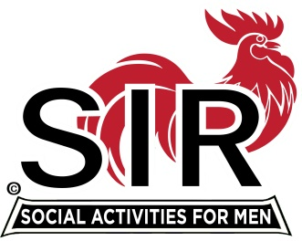
Las Trampas Branch 116
BEC Meeting Agenda
March 30th, 2020, 9:00 AM
The Mission of SIR is to enhance the lives of our members through fun activities, events and luncheons – while making friends for life.

09:00 Coffee Available !!!
- Call to order; Secretary confirm a quorum
- Secretary – Fred Schafer – Approval of February minutes
- Treasurer – Alan Fitzgerald
- Mike Schneider– Attendance. Member issues?
09:15 Big SIR Report – Michael
- Letter from State Chairman: Discussion
- Liability Insurance increase: budget?
- “All activities cancelled until further notice.” 116 Next steps.
- Virtual mtgs?
- Carmel
- Spring Fling

- Emergency telephone line:
- Luncheon phone & email to be used as emergency contacts?
- Voicemail will need changing?

- Sir leaders consider serving for a second year? (Benson)

- Zoom information mtg for all members?

- AOB

- Date for next meeting?

